Adopt-A-Dot
Pride Practice Facility Campaign

In August, the WVU Foundation launched a major fundraising drive towards the money needed to pay for our new band home. As alumni, we are being counted on as a major source of income towards the new facility and field. You can read the full letter here from the WVU Alumni Band, Inc, Officers and Board of Directors that was emailed to all alumni in our database.
We have created a campaign for our alumni band members, current band members, or people that want to make donations in honor/memory of people associated with the band throughout history. This fundraiser has been named the "Adopt-A-Dot" campaign. We are excited about the dot campaign because every former member of the Pride will immediately know what it means and no one else will have a clue.
Important things for you to know:
- Each symbolic dot can be purchased for $250. Our hope is that you will come strong with dot purchases in honor of your time with classmates and friends from your years in the band.
- We are also setting a goal of 1,000 dots purchased in honor of Don Wilcox – and remember, there’s no limit to the number of dots that you can purchase!
- Did you meet your spouse in the band? We are hoping that if you met your spouse in the band you will consider buying 2 dots to show the hundreds of couples that have emerged from the band.
- We would like to see dots purchased for former members who have passed away, but will live on in spirit with us at the new field.
- Finally, we hope that parents and relatives will purchase dots for current members of the band.
A special website has been created for the Pride Practice Facility campaign: https://give.wvu.edu/pridepracticefacility Please be sure to select the box "Adopt-A-Dot" (see graphic below).
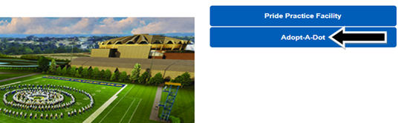
- When buying multiple dots, each one will need to be purchased separately. The Foundation form allows for only one dot purchase at a time.
- The WVU Foundation will be mailing a special fundraising piece in August and we encourage you to LOOK for the “Adopt-A-Dot” information.
- Whether donate on-line or by mail, it is important that you check the box denoting that you are Pride alumni in the donation form so we can mail you your commemorative pin!)
- When donating on-line or by mail, you will have the option to make a recurring gift commitment – bi-weekly, monthly, quarterly, etc. as a payment option.
When you “Adopt-A-Dot,” you will receive a commemorative pin exclusively designed for this groundbreaking fundraiser from the WVU Alumni Band, Inc. We hope you will wear them proudly to demonstrate your commitment to this important project. We want to continue dot sales in the future and keep adding alumni to our ranks as new graduates join us.
This campaign is all about YOU and where YOU stand … do you stand with the Pride of WV?

